Cubist Emotion Painting Reflection Sheet

Date: ___________________________
Name: _______________________________________________
What emotion does your painting convey? _______________________________________________
How did you create the emotion? Explain how you created the emotion in the following areas:
FACE: _________________________________________________________________________________________
_________________________________________________________________________________________________
BODY: _________________________________________________________________________________________
_________________________________________________________________________________________________
BACKGROUND: ______________________________________________________________________________
_________________________________________________________________________________________________
What colour(s) did you use? ________________________________________________________________
Why did you use these/those colour(s)? __________________________________________________
_________________________________________________________________________________________________
_________________________________________________________________________________________________
What is Cubism? _____________________________________________________________________________
_________________________________________________________________________________________________
Where did you use Cubism in your painting? Does Cubism help to convey the emotion you intended to portray? Explain.
________________________________________________________________________________________________________________________________________________________________________________________________________________________________________________________________________________________________________________________________________________________________________________________________________________________________________________________________________________________________________________________________________________________________________________________________________________________________________________________________________________________________________________________________________________________________________________________________________
What is the most successful aspect of your painting? Why? ________________________________________________________________________________________________________________________________________________________________________________________________________________________________________________________________________________________________________________________________________________________________________________________________________________________________________________________________________________________________________________________________________________________________________________________________________________________________________________________________________________________________________________________________________________________________________________________________________
If you can change some aspect of your painting, what would it be and why?
________________________________________________________________________________________________________________________________________________________________________________________________________________________________________________________________________________________________________________________________________________________________________________________________________________________________________________________________________________________________________________________________________________________________________________________________________________________________________________________________________________________________________________________________________________________________________________________________________
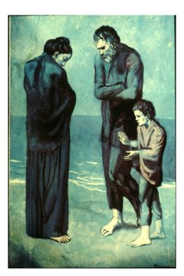
After the death of a close friend, Picasso began to show what he
was feeling in his paintings.
“The Tragedy”, 1903
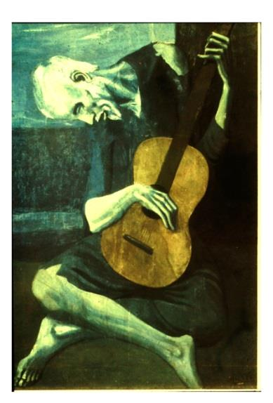
How do you think Picasso showed what he was feeling at this time in his life?
“Old Guitarist”, 1904

